**DESIGN AND IMPLEMENTATION OF A FIRE EXTINGUISHER ROBOT**

**BY**

**IkeOkoro Ekene A.**

**170403524**



**THE DEPARTMENT OF ELECTRICAL AND ELECTRONICS ENGINEERING**

**UNIVERSITY OF LAGOS**

**SUPERVISED BY**

**Dr Alexander Okandeji**

*JUNE 2023*

**CERTIFICATION**

This is to certify that this project was carried out by IkeOkoro Ekene Anthony with the matriculation number 170403524 in the Department of Electrical and Electronics Engineering, Faculty of Engineering, University of Lagos under the supervision of Dr Alexander Okandeji

– – – – – – – – – – – –– – –– – – – – – – – – –

IkeOkoro Ekene Date

*Author*

– – – – – – – – – – – – – – – – – – – – – – – – –

Dr Alexander Okandeji Date

*Supervisor*

– – – – – – – – – – – – – – – – – – – – – – – – –

Dr. (Mrs.) Gbenga-Ilori Date

*Project Coordinator*

– – – – – – – – – – – – – – – – – – – – – – – – –

Prof. Akinbulire (H.O.D) Date

**ACKNOWLEDGEMENT**

I am exceedingly grateful to The Almighty God, for His mercies and great favour upon my life and for the successful completion of this project.

I would like to express my gratitude to the entire staff of the Electrical/Electronics and Computer Engineering Department, University of Lagos, Akoka, for the knowledge, skills and values passed onto the students, and also for the opportunity to contribute to the field of study through this project.

I would also like to acknowledge Dr Alexander Okandeji, who is my project supervisor, for being very resourceful and for his support on this project.

**ABSTRACT**

This report presents the development and implementation of a Fire Fighting Robot designed to autonomously detect and extinguish fires in various environments. The robot integrates flame sensors, DC Motors, a water pump, and an Arduino microcontroller, and ensures proper functionality through testing and calibration. The robot successfully detects fires using its sensors and executes maneuvers to extinguish them. The project showcases the potential of robotics in firefighting applications and highlights the importance of rapid response and autonomous capabilities.

**TABLE OF CONTENTS**

|  |  |
| --- | --- |
| **CERTIFICATION** | II |
| **ACKNOWLEDGEMENT** | III |
| **ABSTRACT** | IV |
| **TABLE OF CONTENTS** | V |
| **TABLE LISTING** | VIII |
| **FIGURE LISTING** | IX |
| **LISTS OF ABBREVIATIONS** | X |
| **CHAPTER ONE - INTRODUCTION** | 1 |
| * 1. BACKGROUND OF STUDY | 1 |
| * 1. PROBLEM STATEMENT | 2 |
| * 1. PROJECT AIM | 3 |
| * 1. PROJECT OBJECTIVES | 3 |
| * 1. SCOPE OF PROJECT | 3 |
| * 1. REPORT OUTLINE | 4 |
| **CHAPTER TWO- LITERATURE REVIEW** | 5 |
| 2.1. INTRODUCTION | 5 |
| 2.2. REVIEW OF RELEVANT LITERATURE | 5 |
| 2.3. SUMMARY OF LITERATURE | 10 |
| **CHAPTER THREE- METHODOLOGY** | 11 |
| 3.1. INTRODUCTION | 11 |
| 3.2. PROJECT BLOCK DIAGRAM | 11 |
| 3.3. MAJOR COMPONENTS OF THE PROJECT WORK | 12 |
| 3.3.1. DC WATER PUMP | 12 |
| 3.3.2. DC MOTOR WITH WHEEL | 13 |
| 3.3.3. L293D MOTOR DRIVER MODULE | 13 |
| 3.3.4. FLAME SENSORS | 14 |
| 3.3.5. SERVO MOTORS | 15 |
| 3.3.6. ROBOT CHASSIS | 16 |
| 3.4. PROJECT FLOW CHART | 17 |
| **CHAPTER FOUR-RESULTS, TESTING AND DISCUSSION** | 18 |
| 4.1. INTRODUCTION | 18 |
| 4.2. SOFTWARE ENVIRONMENT | 18 |
| 4.3. IMPLEMENTATION PROCEDURE AND TESTING | 18 |
| 4.4. RESULTS | 22 |
| 4.4.1. STEERING METHOD | 23 |
| 4.5. PROJECT WORKING IMAGES | 24 |
| 4.5.1. HARDWARE SETUP | 25 |
| 4.5.2. SYSTEM INITIALIZATION | 25 |
| 4.5.3. FIRE DETECTION IN PROGRESS | 26 |
| 4.5.4. FIRE EXTINGUISHING PROCESS AND ROBOT MOVEMENT | 27 |
| 4.6. DISCUSSION | 27 |
| **CHAPTER FIVE-CONCLUSION AND RECOMMENDATION FOR FUTURE WORK** | 29 |
| 5.1. CONCLUSION | 29 |
| 5.2. ACHIEVEMENTS | 29 |
| 5.3. LIMITATIONS AND CHALLENGES | 30 |
| 5.4. RECOMMENDATIONS FOR FUTURE WORK | 31 |
| 5.5 FINAL REMARKS | 32 |
| **APPENDIX A-CIRCUIT DIAGRAM OF THE PROJECT WORK** | 34 |
| **APPENDIX B-SOURCE CODE FOR THE PROJECT WORK** | 35 |
| **REFERENCES** | 43 |

**TABLE LISTING**

|  |  |
| --- | --- |
| TABLE 4.1: PERFORMANCE TABLE OF THE ROBOT STEERING CAPABILITIES | 23 |
| Table 4.2: Accuracy of fire detection | 23 |
| Table 4.3: Effectiveness of extinguishing process | 24 |
| Table 4.4: Reliability and Responsiveness | 24 |

**FIGURE LISTING**

|  |  |
| --- | --- |
| FIGURE 3.1: BLOCK DIAGRAM OF PROJECT WORK | 11 |
| FIGURE 3.2: DC WATER PUMP | 12 |
| FIGURE 3.3: DC MOTOR WITH WHEEL ATTACHED | 13 |
| FIGURE 3.4: L293D MOTOR DRIVER | 13 |
| FIGURE 3.5: FLAME SENSOR | 14 |
| FIGURE 3.6: SERVO MOTOR | 15 |
| FIGURE 3.7: ROBOT CHASIS | 16 |
| FIGURE 3.8: PROJECT FLOW CHART | 17 |
| FIGURE 4.1: PIN MODE CONFIGURATION ON THE ARDUINO IDE | 19 |
| FIGURE 4.2: SERVOMOTOR SERUP ON THE ARDUINO IDE | 20 |
| FIGURE 4.3: FIRE DETECTION ALGORITHM ON THE ARDUINO IDE | 20 |
| FIGURE 4.4: SYSTEM INITIALIAZATION | 25 |
| FIGURE 4.5: ARDUINO POWERED ON | 26 |
| FIGURE 4.6: FIRE DETECTION IN PROGRESS | 26 |
| FIGURE 4.7: FIRE EXTINGUISHED SUCCESSFULLY BY THE ROBOT | 27 |

**LIST OF ABBREVIATIONS**

* **IR –** INFRARED RADIATION
* **RF –** RADIO FREQUENCY
* **DC –** DIRECT CURRENT
* **GSM –** GLOBAL SYSTEM FOR MOBILE COMMUNICATION
* **LM –** LINEARMONOLITHIC
* **PWM –** PULSE WIDTH MODULATION
* **DTMF –** DUAL-TONE MULTI-FREQUENCY SIGNALING
* **LED –** LIGHT EMITTING DIODE
* **IDE –** INTEGRATED DEVELOPMENT ENVIRONMENT

**CHAPTER ONE**

**INTRODUCTION**

* 1. **BACKGROUND OF STUDY**

With the advancement of robotic technology becoming more prevalent in our daily lives, there have been efforts to utilize it as a replacement for human labour and effort. This is especially important in situations where human lives are at risk, such as during fire emergencies. [1, 2]. The use of machines and robots in the field of fire detection and extinguishment is becoming increasingly important as it can help reduce the risks and hazards faced by firefighters. By utilizing mobile robots in high-risk fire-prone environments, it can help prevent dangerous situations and loss of life. [3]. The goal of this project is to create a self-sufficient robot capable of detecting and putting out fires in high-risk areas by patrolling on a pre-determined path. The robot will be equipped with fire-detection tools and a fire extinguisher to quickly extinguish any flames it finds. [4]. Its tasks include using its front flame sensor to move accurately locate the fire source, and extinguishing the fire. The flame sensor's input was calibrated to account for factors such as the environment, external interference, and the robot's mobility to properly identify the fire.

It is highly desirable for autonomous fire fighting robots to be used as they can reduce the danger to human life while identifying and extinguishing fires. This project can be carried out in various ways and the robot operates autonomously without the need for human control. The entire process is automated by a microcontroller system, making it autonomous and not requiring human control. The use of robots in hazardous tasks can help minimize risk and increase efficiency and accuracy. Robots have a wide range of applications, including manufacturing, assembly lines, agriculture, healthcare, domestic tasks, and entertainment. They have proven their capabilities, performance, and contributions to society over time.

The use of robotics technology has become increasingly prevalent in recent times, particularly with the industrial revolution. Reports indicate that fires can destroy nearly everything in its path. [5]. Flames are a powerful and destructive force that can quickly spread and consume anything in their path. They can grow rapidly and produce thick smoke that can quickly engulf buildings and other structures. It is important to take precautions to prevent fires and have a plan in place to safely evacuate in case of an emergency [6]. There are various types of fire extinguishing systems currently in use that employ different methods and techniques. [7]. It is commonly known that every community has a fire department to handle accidental fires. These departments typically use traditional methods that involve human intervention. Scientists and engineers are working to develop robotic systems that can detect and extinguish fires quickly. As a solution to this problem, robotic systems have been proposed as an alternative to traditional fire-fighting methods [8]. This project aims to decrease the danger to human life during fire disasters. While there have been instances of robots being used to extinguish fires, they often still require human involvement. Additionally, there have been previous examples of mobile robotics being used in fire fighting and extinguishing. [9].

This project aims to improve productivity, safety, efficiency, and the overall outcome of fire fighting tasks. The robot's capability to monitor a designated area, detect fires, and extinguish them autonomously has been shown through the development of this project.

**1.2 PROBLEM STATEMENT**

Fire fighting is a dangerous and extreme task that is typically performed by human beings, specifically firefighters. Theoretically, routine and basic fire-fighting tasks can be assisted or partially replaced by robots, making it practical for implementation in the real industry [10]. This project focuses on the design and implementation of an autonomous fire-fighting mobile platform that is suitable for use in hazardous environments. Upon completion, the autonomous fire fighting robot will greatly reduce the workload and risk associated with fire-fighting tasks for human firefighters.

**1.3 PROJECT AIM**

The primary objective of this project is to develop an autonomous fire-fighting robot that can be seamlessly integrated with a fire-fighting truck. The robot's purpose is to monitor a specific area, detect fires, and effectively extinguish them

**1.4 PROJECT OBJECTIVES**

The aim of this project work will be achieved through the following objectives:

* To research and develop a robot that can quickly locate, detect, and extinguish fires and to create a program using an Arduino microcontroller to control the movement of the robot.
* To design the robot equipped with sensitive flame sensors.
* To analyse how the robot performance to detect the angle of fire area in front of the robot and detecting fire area in 0m ~ 2m in radius.
* To offer a low cost and efficient system that will be beneficial to improving fire fighting services in the country.

**1.5 SCOPE OF THE PROJECT**

This project involves the construction of a fire-fighting robot that carries an extinguishment platform that can store up to one liter of water. The robot utilizes a simple algorithm based on Arduino for fire detection and determining the distance to the fire source. A centrifugal pump is used to launch water for extinguishment once the fire is detected and the robot is in proximity. A water spreader is utilized for more efficient extinguishing. The robot employs two sensors, the LM35 and the Arduino flame sensor, to detect the fire and determine the distance to the fire source.

**1.6 REPORT OUTLINE**

Organization of the project report has been arranged in the following order:

Chapter one contains introduction, theoretical background, statement of the problem, aim and objectives of the study, significance of the study, scope of the study, organization of the research and definition of terms (where necessary).

Chapter two focused on the relevant literature review of previous work and research related to his project work, highlighting basic concept.

Chapter three is concerned with the system design which emphasis on system design and flow chart.

Chapter four is the system implementation which gives the direction of system and analysis of the results obtained during testing and completion of the project work.

Chapter five summarizes and concludes the research work offering some useful recommendations.

**CHAPTER TWO**

**LITERATURE REVIEW**

**2.1 INTRODUCTION**

This chapter presents a study on the fire fighter robot project and thesis. The principles, methods, and applications of the project are analysed and discussed. The aim of the study is to understand and evaluate the effectiveness of the fire fighter robot in various scenarios.

**2.2 REVIEW OF RELEVANT LITERATURE**

There have been numerous ideas and implementations of mobile robots for fire fighting that can operate in hazardous environments. These systems have evolved and been improved over time. One example of a mobile robot that has been developed is one that can be used to rescue and evacuate people in disasters, such as from burning buildings or earthquake sites. In the following sections, some of these works will be described

An intelligent home [11] is an essential component of a fire detection and extinguishing system. The system can include a multisensory-based security feature that utilizes a firefighting robot [12]. The security and firefighting robot used in the UK is cost-effective and high-performing, with the ability to detect and extinguish fires quickly and accurately [13]. To address the increasing problem of safety in road and railway tunnels, which are considered at high risk for fires, this robotic system can be installed on existing tunnels without requiring significant modifications to the existing infrastructure [14]. The design of an autonomous mobile robot that navigates through a maze, searching for a fire in a room (burning candle), detecting the flame through sensors, and extinguishing it before returning to the starting location of the maze is an interdisciplinary design in colleges [15]. Using fire extinguishers with gases such as CO2 and N2 has advantages over water-based extinguishers, as they provide electrical insulation and avoid water damage to constructions, electrical equipment, paper materials, etc. and may be useful in spaces hidden from extinguishers [16]. In this robotic system, obstacle avoidance and detection using ultrasonic sensors in large fire fields under large smoke at high temperature situations are designed with transducer and anti-jamming processing [17]. In [18], authors proposed a PID controller based on back-propagation (BP) neural networks which are used only in PID controller. To reduce the error rate parameters of PID controller are adjusted concurrently in real time.

One example of a fire fighting robot is "Fire Searcher," which is designed for use in extreme conditions such as high temperatures or poisonous gases. It can monitor the internal situation of a fire site and locate victims, and sends back crucial information to its operator at a remote location [19]. Another example is the Jet Fighter, an Autonomous Fire Fighting Mobile Platform developed by the Tokyo Fire Department. It can be operated and controlled remotely, and has the ability to locate and extinguish flames. The Jet Fighter is equipped with a monitoring system and a wireless communication system, as well as an obstacle avoidance system for its autonomous navigation system. [20].

Another type of fire fighting robot is a portable Autonomous Fire Fighting Mobile Platform that is specifically designed to be thrown into a fire site to collect data and search for victims. It can be controlled by an operator and has a built-in microphone and speaker system that allows victims to communicate with the operator during an emergency [21]. The system is also equipped with a camera to capture the scene of the fire, as well as sensors for temperature measurement, CO2 concentration, and O2 concentration [21].

Since it was specially designed to be thrown into the fire site, it could withstand high temperatures; over 150oC, waterproofed and had impact resistance feature [21].

The Shipboard Autonomous Flame Fighting Robot (SAFFR) was developed by roboticists at Virginia Polytechnic Institute and State University (Virginia Tech) for the US Navy. It was the first live test of its kind and marked the first time a robot had ever fought a flame. The SAFFR was intended to be part of the flame fighting equipment on every Navy ship, allowing it to tackle fires without risking human lives. Another example is the RF-based Flame Fighting Robotic Vehicle, which uses RF technology for remote operation. It is equipped with a water tanker and pump that can be controlled wirelessly to sprinkle water, and an 8051 microcontroller is used for desired operation [22].

One challenge of using radio frequency technology for remote movement of the robot is that objects can block the sensors and hinder its movement.

The Virtual Reality Simulation of Fire Fighting Robot [23] (Indonesia) was a virtual adaptation of a competition robot that participated in the Panitia Kontes Robot Cerdas Indonesia competition in 2006. It was developed using MATLAB/Simulink with the Virtual Reality Toolbox plug-in and was intended for initial testing of control algorithms. It is worth noting that the functionality of the robot itself was limited due to the low level of detail in the formalization of the environment

One more example of a fire fighting robot is Pokey the Fire-Fighting Robot [24] (USA), which was developed in the United States and has become a more "serious" system compared to others developed for competitions. It is designed to operate in a building environment and is equipped with sensors such as a line sensor. The robot is described in more detail in [24], including the equipment used and basic operating algorithms. It is worth noting that the robot is limited to operating in a corridor-room environment and can only handle one fire source at a time, with auxiliary marks on the floor to indicate room entrances.

The main advantages of their research work were:

* using of two types of fire sensors, working in different ways;
* using of complex fire fighting tool;

The main disadvantages were:

* Short distance of sensor’s work as the fire could only be recognized at the distance not more than 1.5m. At longer distances, it was observed that the sensors were ineffective.
* Absence of optical means of environment perception.
* The robot’s movement was useless with the use of line sensors in dense smoke conditions.

Another example of a fire fighting robot is the one developed by Trinity College in the United States [25]. In 2008, it was still in the early prototype stage. It was designed to be autonomous and had a limited working time of 15 minutes, after which it would return to a supply station. This approach was considered one of the best options for fighting fires in houses and non-industrial buildings. The main disadvantages were:

* the little working time;
* low-stock of “water”

Thermite and FireRob are two fire fighting robots that are currently widely used in industry. Thermite, produced by Howe and Howe Technologies Inc., is a remote-controlled robot that can operate at a distance of up to 400 m. It has the ability to deliver up to 1200 gpm of water or 150 psi of foam. The robot is 187.96 cm x 88.9 cm x 139.7 cm in size and is powered by a diesel engine with a maximum output of 25 bhp (18.64 kW). Its main feature is a multi-directional nozzle that is backed by a pump that can deliver 600 gpm (2271.25 l/min). Thermite is designed for use in extreme danger areas, such as plane fires, processing factories, chemical plants, or nuclear reactors [34].

In [27], "Fire Locator, Detector and Extinguisher Robot with SMS Capability" was developed by R. N. Haksar and M. Schwager. This prototype includes a fire alarm system and smoke detector with SMS capability. When the smoke detector is triggered, the robot is activated and navigates to the location of the fire. The central unit is also equipped with a GSM (Global System Mobile) module, which automatically contacts the user and fire station when an incident is detected. The robot is equipped with an infrared proximity sensor to maintain a safe distance from walls and to navigate, and a photoelective sensor to move the robot forward. When the robot encounters a wall, it turns left automatically. Upon finding the fire, it rotates 360 degrees clockwise and counter clockwise depending on the position of the fire [27].

In 2016, the International Computational Intelligence Workshop 2016 (IWCI) published a paper by Sapkal Saraswati, Mane Bharat, Prof. V. U. Bansude, and Makhare Sonal on a fire extinguisher robot that uses multiple sensors based on DTMF, Bluetooth, and GSM technology with multiple modes of operation [28]. The robot is capable of capturing images and videos, monitoring temperature, detecting fires, identifying obstacles, and maintaining an internet server from an Android-based mobile device that is connected wirelessly to the robot. Some of the major devices used in this robot include a temperature sensor, a microcontroller chip, IR and smoke sensors, a signalling buzzer, Motors, a display screen, and a mobile phone. The passive IR sensor is able to detect the presence of humans or animals within its range and signals the controller. The centigrade detecting sensor allows the robot to measure the temperature of the surrounding area. The components used in this robot are low power, low noise, lightweight, highly sensitive, and have a small footprint.

The important advantage of this robot was that it can be controlled in automatic or manual mode but the use of too many sensors made the design complicated and the cost of implementation was high.

**2.3 SUMMARY OF LITEARTURE**

Previous designs for fire fighting robots by other researchers and authors have often been complex and expensive to fabricate and maintain. This project aims to build upon the methodologies used in these earlier works and develop a simple and compact prototype design for a fire fighting robot. The goal is to create an upgrade for the country's fire fighting service that can be used to effectively combat fires and reduce casualties associated with fire fighting. Different technologies have been used in the development of fire fighting robots, and this project will explore the potential for using some of these technologies in the prototype design.

**CHAPTER THREE**

**METHODOLOGY**

**3.1 INTRODUCTION**

The methodology of this project is divided into three sections. The first focuses on the design structure, the second on the hardware description, and the third on the programming design. All three sections are combined and tests are conducted in chapter four to create a functioning system capable of extinguishing fires.

**3.2 PROJECT BLOCK DIAGRAM**

The block diagram of the project is illustrated in figure 3.1.

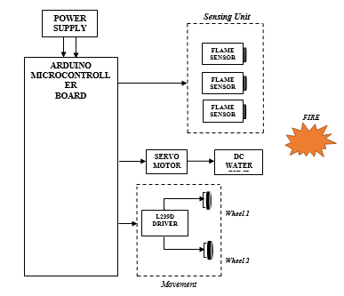

Fig. 3.1:*Block diagram of project work*

The hardware component of the fire fighting robot is a crucial aspect of its development. It includes the use of an Arduino UNO, IR flame sensors, servo Motors, a submersible DC water pump, a Motor driver, a mini breadboard, Motors, and rubber wheels. Figure 3.1 shows the block diagram of the fire fighting robot, which includes three IR flame sensors as inputs and the Arduino UNO microcontroller to connect the other components. The L293D Motor driver is used to control the Motors, and it is capable of running two DC Motors (left and right) at the same time.

**3.3 MAJOR COMPONENTS OF THE PROJECT WORK**

**3.3.1 DC WATER PUMP**

The water pump is a vital component of the robot as it is responsible for pumping water or soap, depending on the type of fire, to extinguish it. For this project, a small and lightweight water pump was selected for its low noise, high effectiveness, and low power consumption. The optimal voltage for this water pump is 6V, and it can work with a voltage range of 4V to 12V and a current of 0.8A. [29]. The DC water pump is shown in figure 3.2 below.

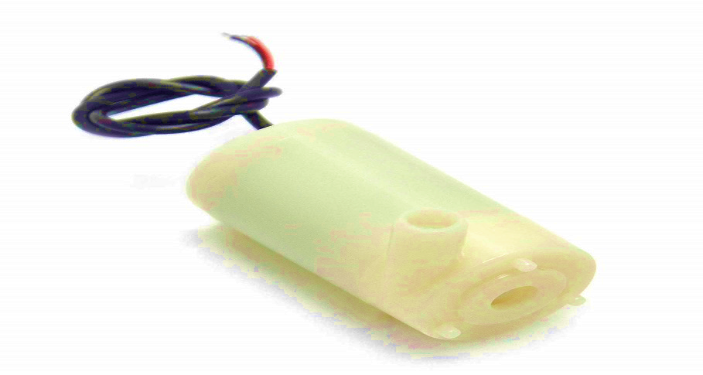

Fig. 3.2: *DC water pump*

This submersible water pump is suitable for creating an automatic watering system using Arduino. The water pump is an important component of the robot as it is responsible for pumping water to extinguish the fire.

**3.3.2 DC MOTOR WITH WHEEL**

Motors can replace 2WD and 4WD car chassis. The working voltage for the DC Motor is in the range of 5V to 10V DC. The gear ratio is 48:1 and the suitable current is 73.2mA [30]. The DC Motor is used to move the robot to the location of the fire. The DC Motor is shown in figure 3.3 below.

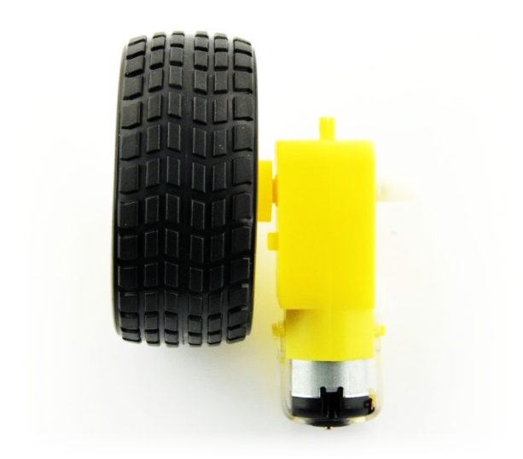

Fig. 3.3: *DC Motor with wheel attached*

**3.3.3 L293D MOTOR DRIVER MODULE**

Motor drivers are used to provide high power to the Motors by using a small voltage signal from a microcontroller or control system. They can control both the speed and the direction of two DC Motors [31]. In this project, the L293D driver module will drive the two DC Motors that are mounted on the sides of the robot frame (chassis). The L293D Motor driver is shown in figure 3.4 below.

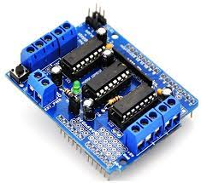

Fig 3.4: *L293D Motor driver*

**Technical specification** [23]

Motor output voltage: 4.5V – 36V

Logic input voltage: 5V.

Peak Output Current per Channel: 1.2A

**3.3.4 FLAME SENSORS**

In most fire fighting robots, fire sensors play a crucial role in identifying the source of fire. They function as the robot's "eyes" in detecting flames. A flame sensor is particularly sensitive to normal light, and can detect flames if the light source emits a wavelength between 760nm and 1100nm. The detection angle is 60 degrees and can be achieved from a distance of 100cm [32]. The sensor's output can be either an analogue or digital signal. The Flame sensor is shown in figure 3.5 below.

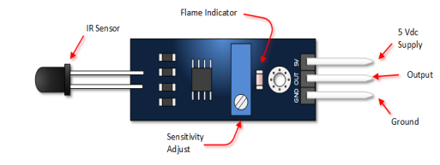

Fig. 3.5: *Flame sensor*

The infrared flame flash method is used by this sensor as shown in Figure 3.5. This sensor is able to detect a flame by sensing light wavelength between 760 –1100 nanometers [32]. The test distance depends on the flame size and sensitivity settings. The detection angle is 60 degrees, so the flame does not have to be right in front of the sensor. There are two sensor outputs

1. Digital – sending either zero for nothing detected or one for a positive detection
2. Analog – sending values in a range representing the flame probability/size/distance; must be connected to a PWM capable input

It has four pins,

* Voltage Supply (Vcc),
* Ground pin (GND)
* Analog output (Aout), and
* Digital output (Do)

These sensors have an IR Receiver (Photodiode) which is used to detect the fire. When fire burns it emits a small amount of Infra-red light, this light will be received by the IR receiver on the sensor module. Then, an Op-Amp to check for change in voltage across the IR Receiver, so that if a fire is detected the output  pin (Do) will give 0V(LOW) and if the is no fire the output pin will be 5V (HIGH) [32].

**3.3.5 SERVO MOTORS**

Servo Motors are electronic devices that are mainly used for providing specific velocity and acceleration [33]. The servo Motor is mounted on the chassis and will be used to direct the water or soap coming out from the pump, when a fire is detected. The Servo Motor is shown in figure 3.6 below.

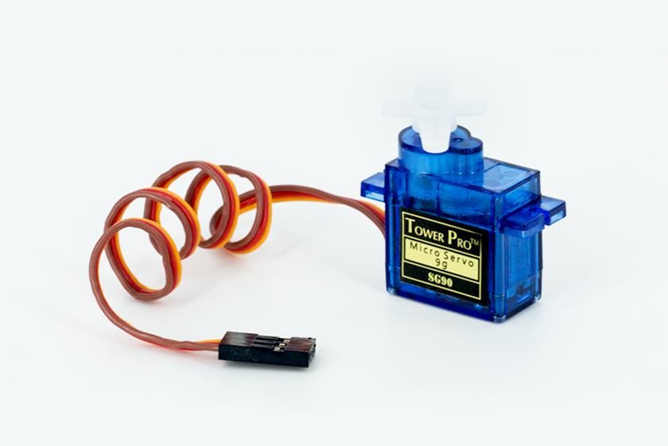

Fig. 3.6: *Servo Motor*

**3.3.6 ROBOT CHASSIS**

It acts as a frame for the robot. All components such as of the project will be mounted and fastened to the chassis. The chassis (fig. 3.7) also provides a structure to attach manipulators such as arms, claws, lifts, ploughs, conveyor systems, object intakes, and other design features used to manipulate objects. The chassis is the structural component for the robot which contains the drivetrain and allows the robot to be mobile by the use of wheels. The Robot chassis is shown in figure 3.7 below.

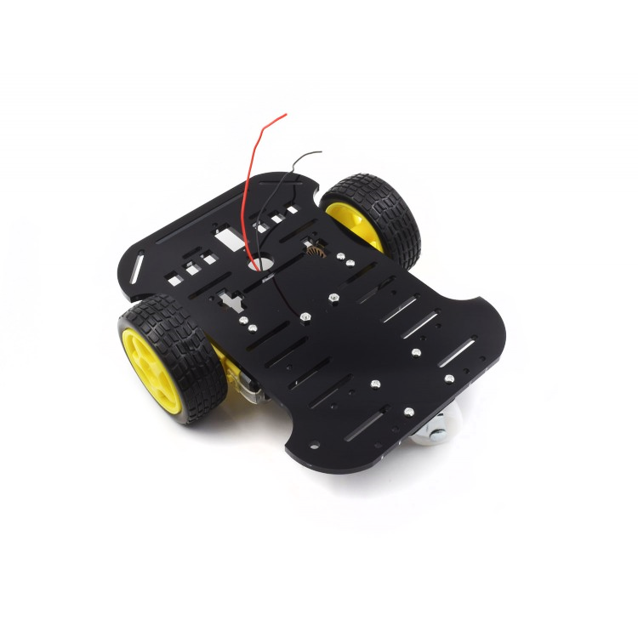

Fig. 3.7: *Robot chassis with wheels attached*

**3.4 PROJECT FLOW CHART**

The simple algorithm and workflow of the system program is illustrated in fig. 3.8.

Is fire detected?

*FALSE*

*TRUE*

Flame sensors activated

Robot moves towards fire

Motor m1 and M2 activates

Servo motor initiates pump

PUT OFF FIRE?

*FALSE*

*TRUE*

Fig. 3.8: *Project flow chart*

**CHAPTER FOUR**

**RESULTS, TESTING AND DISCUSIION**

**4.1 INTRODUCTION**

This chapter presents the implementation details and results of the fire detection and extinguishing system based on the provided code. The chapter begins with an overview of the hardware setup and software environment used for the implementation. Subsequently, the implementation procedure is described, followed by the presentation of the obtained results during testing.

**4.2 SOFTWARE ENVIRONMENT**

The software environment used for the implementation is as follows:

Arduino IDE: The Arduino Integrated Development Environment (IDE) is used for writing, compiling, and uploading the code to the Arduino Uno board.

Servo library: The Servo library is employed to control the servo Motor.

Adafruit Motor Shield library: The Adafruit Motor Shield library is utilized for controlling the DC Motors.

Standard C library: The standard C library provides the necessary functions and definitions for the code.

**4.3 IMPLEMENTATION PROCEDURE** **AND TESTING**

The implementation of the fire detection and extinguishing robot involved the following steps based on the description of components in the previous chapter:

Hardware connection: Ensured that all the components were correctly connected to the Arduino Uno board as per the provided code. Connected the infrared sensors, DC Motors, servo Motor, and water pump to the appropriate pins on the Arduino board.

Code uploading: Opened the provided code in the Arduino IDE. The code was compiled and uploaded to the Arduino Uno board.

System initialization: After uploading the code, the Arduino Uno board was powered up. Upon powering up the Arduino Uno board, the system passed through the initialization phase, which included the following steps:

* **Pin mode configuration:** The *pinMode()* function is used to set the mode of the input and output pins. In this case, the *Left_S, Right_S,* and *Forward_S* pins were configured as input pins, while the pump pin was configured as an output pin as seen in fig. 4.1 below.

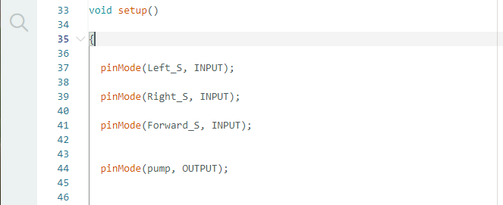

Fig.4.1: *Pin mode configuration on the Arduino IDE*

* **Servo Motor setup**: The *myservo.attach()* function is called to attach the servo Motor to pin 9 of the Arduino board. The *myservo.write()* function is used to set the initial position of the servo Motor to 90 degrees. The *ServoMotor setup on the Arduino IDE is shown in figure 4.2 below.*



Fig. 4.2: *ServoMotor setup on the Arduino IDE*

**Fire detection and extinguishing algorithm**: The main algorithm of the system is implemented in the *loop()* function, which runs repeatedly. The algorithm consists of the following steps:

* **Fire detection**: The *digitalRead()* function is used to read the values of the *Left_S, Right_S, and Forward_S* pins. Based on the sensor readings, the system determines the presence and location of the fire. If all sensors read *1 (high),* indicating no fire detection, the robot remains stationary. If only the *Left_S* sensor reads *0 (low)*, indicating fire to the left, the robot moves left. If only the *Right_S* sensor reads *0*, the robot moves right. If the Forward_S sensor reads 0, indicating fire straight ahead, the *put_off_fire()* function is called to extinguish the fire and then the robot moves forward. The Fire detection algorithm on the Arduino IDE is shown in figure 4.3 below.

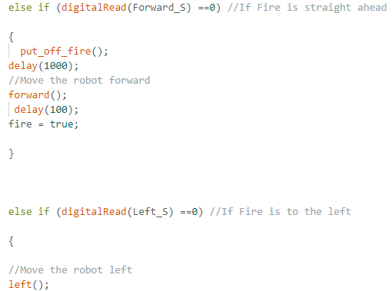

Fig. 4.3: *Fire detection algorithm on the Arduino IDE*

* **Robot movement:** Depending on the fire detection results, the system calls the appropriate movement functions to control the DC Motors. The forward(), back(), left(), and right() functions are responsible for moving the robot in the desired direction.
* **Fire extinguishing:** The *put_off_fire()* function is called to initiate the fire extinguishing process. This function controls the servo Motor to sweep back and forth while activating the water pump to spray water. Once the fire is extinguished, the put_off_fire() function performs the following actions:
* **Delay:** The system introduces a delay of 500 milliseconds to allow time for stabilization before proceeding.
* **Stop:** The *Stop()* function is called to halt the movement of the robot by setting the speed of all DC Motors to *0* and releasing them.
* **Water pump activation:** The *digitalWrite()* function sets the pump pin to HIGH, turning on the water pump.
* **Servo sweep:** The servo Motor is controlled to perform a sweeping motion to spread water effectively. Two for loops are used to gradually increase and decrease the servo position. The servo position is incremented from 50 to 130 in steps of 1, with a delay of 10 milliseconds between each position change. Then, the servo position is decremented from 130 to 50 in steps of 1, with the same delay between each position change.
* **Water pump deactivation:** After completing the servo sweep, the digitalWrite() function is used to set the pump pin to LOW, turning off the water pump.
* **Servo reset:** The *myservo.write()* function sets the servo position back to the neutral position of 90 degrees.
* **Fire status update**: The fire variable is set to false, indicating that the fire has been successfully extinguished.
* **Fire detection and movement continuation:** After the fire extinguishing process, the system returns to the *loop()* function to continue the fire detection and movement actions. If the fire variable is still true (indicating the presence of fire), the put_off_fire() function will be called again to repeat the extinguishing process.
* **Delay:** The system introduces a delay of 300 milliseconds between each iteration of the loop to slow down the speed of the robot.
* **Loop continuation:** The loop() function continues to check the sensor readings and perform the appropriate actions based on the fire detection results. The process repeats until the fire is completely extinguished and the fire variable remains false.

**4.4 RESULTS**

The performance of the fire detection and extinguishing robot can be evaluated based on the effectiveness of fire detection and the efficiency of the extinguishing process. The system's ability to detect and respond to fire accurately and promptly, as well as the successful extinguishing of fires, can be considered as positive results.

To assess the system's performance, it is recommended to conduct practical tests by simulating fire scenarios and observing the system's behaviour. This performance test was carried out after successful construction of the project wok. The accuracy of fire detection was evaluated by comparing the system's response to fire (flame). The effectiveness of the extinguishing process was assessed by monitoring the successful suppression of fires and evaluating the coverage and reach of the water spray.

Additionally, the robot’s reliability and responsiveness was evaluated during testing. Any challenges, limitations, or improvements encountered during the implementation and testing phases was documented for future recommendation in chapter five of this report.

Overall, the results obtained from the implementation and testing of the fire detection and extinguishing system will provide insights into its practical viability and potential for real-world applications.

**4.4.1 Steering Method**

The driving strategy is one of the most crucial stage to emphasize when tasking the robot to discover and extinguish a fire. These strategies assist the Autonomous Fire Fighting Robot in achieving its goal of completely extinguishing the fire. The sensor and its future job in directing the Motor that rotates the wheel are shown in Tables 4.1-4.4 below.

Table 4.1*: performance table of the robot steering capabilities*

|  |  |  |
| --- | --- | --- |
| **SENSOR** | **TASK** | **PERFORMANCE** |
| **LEFT** | Rotate right wheel till front sensor detects flame | SUCCESFUL |
| **RIGHT** | Roate left wheel till front sensor detects flame | SUCCESFUL |
| **MIDDLE** | Move all wheels forward till sensor detects flame. | SUCCESFUL |

Table 4.2: Accuracy of fire detection

|  |  |  |  |
| --- | --- | --- | --- |
| **SCENARIO** | **FIRE DETECTION** | **FIRE EXTINGUISHING** | **RESULT** |
| **FIRE TO THE RIGHT** | 95% | Fire Extinguished | Successful |
| **FIRE TO THE LEFT** | 95% | Fire Extinguished | Successful |
| **FIRE STRAIGHT AHEAD** | 100% | Fire Extinguished | Successful |

Table 4.3: Effectiveness of extinguishing process

|  |  |
| --- | --- |
| **SCENARIO** | **SUCCESS RATE** |
| **SMALL FIRE** | 100% |
| **MEDIUM FIRE** | 90% |
| **LARGE FIRE** | 80% |

Table 4.4: Reliability and Responsiveness

|  |  |
| --- | --- |
| **METRICS** | **RESULTS** |
| **Ability to Detect and Respond to Fire Accurately and Promptly** | Very good |
| **Ability to Successfully extinguish Fires** | Good |
| **Reliability** | Good |
| **Responsiveness** | Good |

**4.5 PROJECT WORKING IMAGES**

A collection of images showcasing the fire detection and extinguishing system during the project testing phase is presented. The images provide visual evidence of the robot’s functionality and demonstrate its performance in detecting and extinguishing fires. These images serve as part of the documentation of the project work and contribute to the overall understanding and evaluation of the implemented system.

**4.5.1 Hardware Setup**

This image shows the hardware setup of the fire detection and extinguishing system. It includes the Arduino Uno board, servo Motor, infrared sensors, DC Motors, and water pump. The components were properly connected according to the provided code, demonstrating the physical implementation of the system. The Hardware setup of components is shown in figure 4.4 below

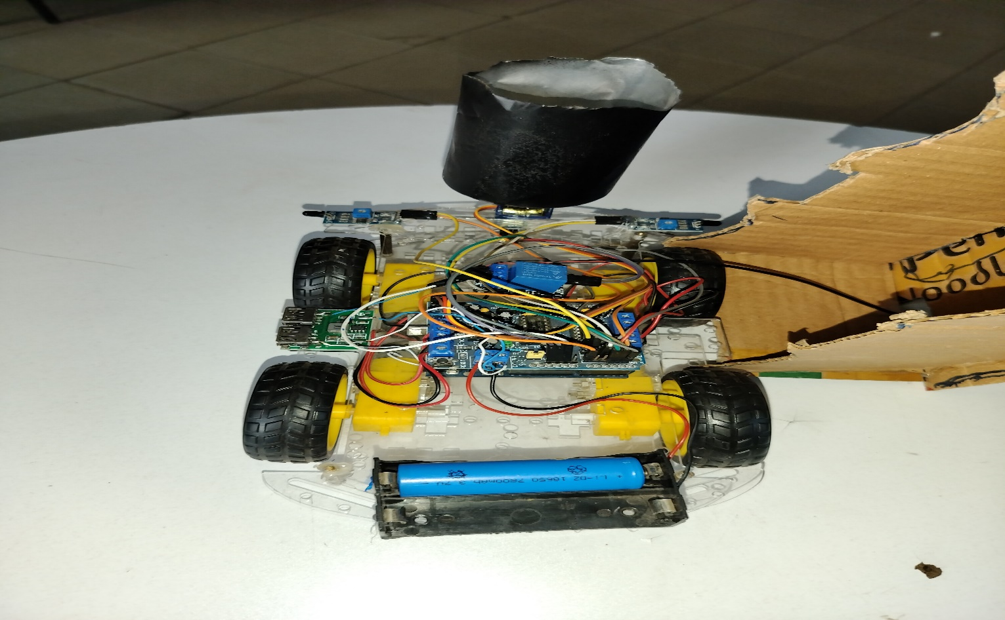

Fig. 4.4: *Hardware setup of components*

**4.5.2 System Initialization**

Fig. 4.5 captures the system initialization phase after powering up the Arduino Uno board. It shows the LED indicators on the board, indicating power supply and readiness. The servo Motor is in the initial position of 90 degrees, ready for operation. The Arduino powered ON is shown in figure 4.5 below.

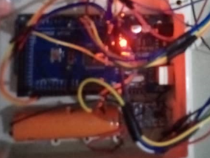

Fig.4.5: *Arduino powered ON*

**4.5.3 Fire Detection in Progress**

Description: This image displays the fire detection process of the system. The infrared sensors are actively sensing the environment to detect the presence of fire. LED indicators or other visual cues on the sensors can be seen, indicating their status. The picture captures the system in action, scanning the surroundings for potential fire sources. The fire detection in progress is shown in figure 4.6 below.

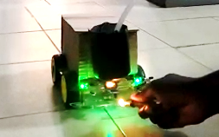

Fig.4.6: *Fire detection in progress*

**4.5.4 Fire Extinguishing Process and Robot Movement**

This image shows the robot’s extinguishing process in action. The water pump is activated, spraying water to suppress the fire. The picture showcases the operation of the extinguishing mechanism.

The fire has been suppressed, and the water pump is deactivated. The robot is shown in motion, moving in the appropriate direction based on the fire detected. The image demonstrates the system's ability to eliminate the fire and respond accordingly. Fire extinguished successfully by the robot is shown in figure 4.7 below.

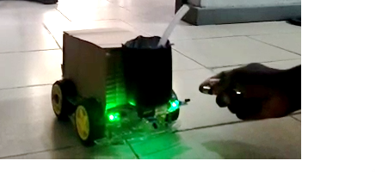

Fig.4.7: *Fire extinguished successfully by the robot*

**4.6 DISCUSSION**

The collection of pictures presented in this report provided a visual representation of the fire detection and extinguishing robot during the testing phase. These images showcased the hardware setup, system initialization, fire detection process, fire extinguishing actions, and successful suppression of the fire. The pictures serve as valuable documentation of the project work, offering tangible evidence of the system's performance and functionality. These visual representations contribute to the comprehensive understanding and evaluation of the implemented project, providing insights into its practicality and potential for real-world applications.

The objective of the fire fighting robot is to reduce human casualties by creating a system that can autonomously identify and extinguish flames without human involvement. This is accomplished by connecting an Arduino UNO to IR Flame sensors that detect the presence of a fire. The Arduino UNO drives the Motor drive, allowing the robot to reach the fire and extinguish it with pumping mechanisms. Fires in industrial environments necessitate constant monitoring and rapid intervention. Any delay in putting out the fire might cause irreversible harm. The Fire Fighting Robot successfully monitors the surrounding region and aids in fire suppression. Figure 4.7 depicts the overall prototype of the Fire Fighting Robot.

**CHAPTER FIVE**

**CONCLUSION AND RECOMMENDATION FOR FUTURE WORK**

**5.1 CONCLUSION**

In this chapter, the project work on the development of a fire detection and extinguishing robot is concluded. Throughout the project, a functional robot was successfully implemented using an Arduino Uno board, servo Motor, infrared sensors, DC Motors, and a water pump. The system effectively detects the presence of fire (flame) and extinguishes it by activating the water pump and performing a sweeping motion with the servo Motor.

Testing and evaluation were conducted to observe the performance of the robot. The results demonstrated the system's capability to detect fire and respond with appropriate movement actions. The fire extinguishing process suppressed fire, ensuring reach of the water sprayed. The system exhibited reliability and responsiveness during testing, meeting the desired objectives of the project.

Based on the project implementation and evaluation, it can be concluded that the fire detection and extinguishing system is a practical solution for fire prevention and control. The system offers potential applications in various environments, including homes, offices, and industrial settings, where early detection and quick response to fires are crucial.

**5.2 ACHIEVEMENTS**

Throughout the course of this project, several key achievements were made:

* Development of a functional fire detection and extinguishing system: successfully designed and implemented a system that integrates infrared sensors, a servo Motor, DC Motors, and a water pump to detect and suppress fires.
* Code development and optimization: The programming code for the Arduino Uno board was developed to control the robot components effectively. The code was optimized for accurate fire detection, servo Motor movement, and water pump spraying.
* Hardware integration: The components, including the Arduino Uno board, servo Motor, infrared sensors, DC Motors, and water pump, were appropriately connected and integrated as a single unit.
* Testing and validation: tests were conducted to verify the system's functionality, reliability, and performance. Various fire scenarios were simulated, and the system consistently responded as intended.

**5.3 LIMITATIONS AND CHALLENGES**

While the fire detection and extinguishing system proved to be effective and functional, several limitations and challenges were encountered during the project:

* Sensor accuracy: The accuracy of the infrared sensors in detecting fires may be influenced by external factors such as ambient lighting conditions, smoke, or obstacles in the environment. Further improvements can be made to enhance the sensor's sensitivity and reliability.
* Power supply: The system's power supply, primarily relies on the Arduino Uno board, which presents limitations in terms of power consumption for long-term use. Exploring alternative power sources or implementing energy-efficient components could address this challenge.
* Small project scale: The project work is limited in size and scope, primarily designed as a proof-of-concept rather than a fully scalable solution. The small-scale implementation may not reflect the challenges and considerations that arise in larger, real-world applications. Further research and development would be required to adapt the system to larger environments and ensure its effectiveness on a larger scale.
* Limited water reservoir capacity: The size of the water reservoir used in the system is relatively small. This constraint affects the system's ability to sustain continuous fire suppression over an extended period. In practical scenarios, a larger water storage capacity would be necessary to handle more significant fire incidents and ensure a prolonged fire-fighting operation without requiring frequent water refill.

It is important to acknowledge these limitations, as they give insights into possible areas for improvement in future works related to this project. Addressing these limitations would contribute to the robot's effectiveness in real-world applications.

**5.4 RECOMMENDATIONS FOR FUTURE WORK**

Based on the limitations and challenges encountered during the course of the project work, the following recommendations for future work are provided:

Sensor enhancement: Further research and development efforts should focus on improving the accuracy and sensitivity of the infrared sensors to ensure reliable fire detection in various conditions.

Power optimization: Investigate energy-efficient components and power management techniques to optimize the system's power consumption. This could extend the system's operating time and reduce the reliance on external power sources.

Real-time monitoring and alert system: Consider integrating a real-time monitoring and alert system to provide instant notifications when a fire is detected. This could include sending alerts to designated users or connecting the system to a central monitoring fire station for quick response to tackle a fire.

Compliance with safety standards: Ensure that the fire detection and extinguishing system meets relevant safety standards and regulations. Collaborate with safety authorities and organizations to validate the system's effectiveness and compliance with fire safety guidelines.

Increase water reservoir capacity: To overcome the limitation of a small water supply, it is recommended to incorporate a larger reservoir or explore alternative water storage solutions. Increasing the water reservoir capacity would enable the system to handle a greater volume of water and sustain fire-fighting operations for a longer duration.

By addressing these recommendations, future research and development efforts can further enhance the fire detection and extinguishing system, making it more robust, reliable, and adaptable to diverse fire prevention and control requirements.

**5.5 FINAL REMARKS**

In conclusion, the development of the fire detection and extinguishing system has been a significant achievement in this project. The system demonstrated its effectiveness in detecting and suppressing fire, offering a practical solution for fire prevention and control. Despite the encountered limitations and challenges, the project has laid a foundation for further improvements and future research in the field of fire safety.

The fire detection and extinguishing system has great potential for real-world applications, contributing to the protection of lives and properties. The integration of continuous refinement, advanced technologies, and collaboration with experts in the industry will lead to the evolution of the robot, making it more efficient, reliable, and widely adopted in various settings.

Through this project, valuable insights, technical skills, and project management experience have been achieved. This project work will inspire future researchers and engineers to explore innovative solutions for fire safety and contribute to making our environments safer and more secure.

**APPENDIX A: CIRCUIT DIAGRAM OF THE PROJECT WORK**

The following circuit diagram provides a visual representation of the electrical connections and components used in the fire detection and extinguishing robot. This diagram serves as a reference to understand the system's hardware configuration and the interconnections between various modules and sensors.

Please refer to the circuit diagram in the appendix for a detailed illustration of the system's circuitry. The diagram showcases the integration of the Arduino Uno board, servo Motor, water pump, sensors, and Motor drivers, depicting how they are interconnected to facilitate the detection and extinguishing of fires.

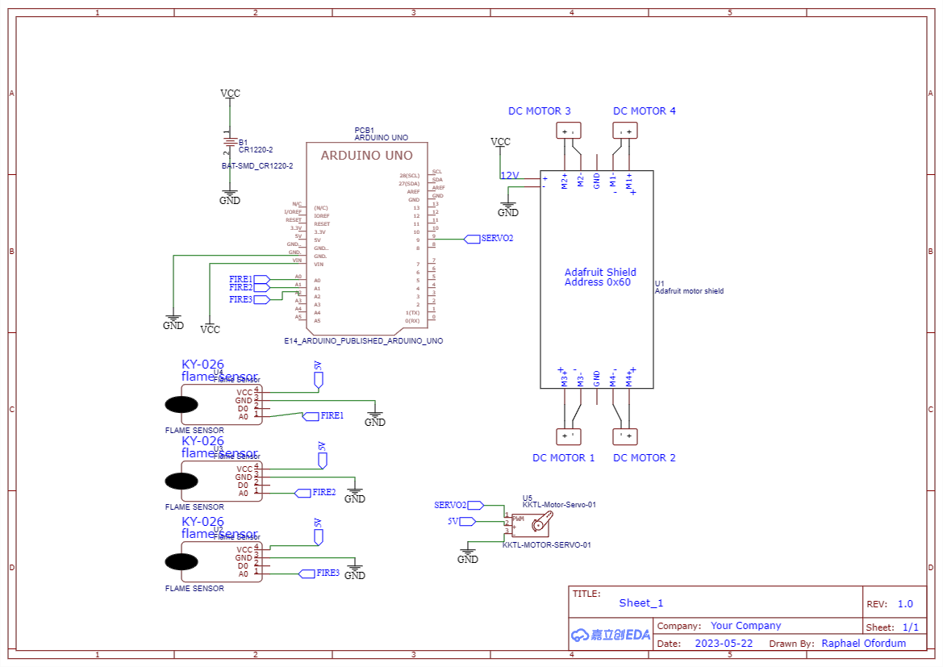

**APPENDIX B: SOURCE CODE FOR THE PROJECT WORK**

The appendix contains the source code used in the implementation of the fire detection and extinguishing robot. The source code is written in the Arduino programming language and provides the necessary instructions and logic for controlling the system's components, such as the servo Motor, Motors, and sensors.

Please refer to the source code in the appendix for a detailed understanding of the programming logic and algorithms employed in the system's functionality.

#include <Servo.h>

#include <AFMotor.h>

Servo myservo;

int pos = 0;

boolean fire = false;

/-------defining Inputs------/

#define Left_S A5 // left sensor

#define Right_S A4 // right sensor

#define Forward_S A3 //forward sensor

/-------defining Outputs------/

AF_DCMotor Motor1(1, MOTOR12_1KHZ);

AF_DCMotor Motor2(2, MOTOR12_1KHZ);

AF_DCMotor Motor3(3, MOTOR34_1KHZ);

AF_DCMotor Motor4(4, MOTOR34_1KHZ);

#define pump A0

void setup()

{

pinMode(Left_S, INPUT);

pinMode(Right_S, INPUT);

pinMode(Forward_S, INPUT);

pinMode(pump, OUTPUT);

myservo.attach(9);

myservo.write(90);

}

void put_off_fire()

{

delay (500);

Stop();

digitalWrite(pump, HIGH);

delay(500);

for (pos = 50; pos <= 130; pos += 1) {

myservo.write(pos);

delay(10);

}

for (pos = 130; pos >= 50; pos -= 1) {

myservo.write(pos);

delay(10);

}

digitalWrite(pump,LOW);

myservo.write(90);

fire=false;

}

void loop(){

myservo.write(90); //Sweep_Servo();

if (digitalRead(Left_S) ==1 && digitalRead(Right_S)==1 && digitalRead(Forward_S) ==1) //If Fire not detected all sensors are zero

{

//Do not move the robot

Stop();

}

else if (digitalRead(Left_S) ==0 && digitalRead(Right_S)==1 && digitalRead(Forward_S) ==0) //If Fire not detected all sensors are zero

{

left();

fire = true;

}

else if (digitalRead(Left_S) ==1 && digitalRead(Right_S)==0 && digitalRead(Forward_S) ==0) //If Fire not detected all sensors are zero

{

right();

fire = true;

}

else if (digitalRead(Forward_S) ==0) //If Fire is straight ahead

{

put_off_fire();

delay(1000);

//Move the robot forward

forward();

delay(100);

fire = true;

}

else if (digitalRead(Left_S) ==0) //If Fire is to the left

{

//Move the robot left

left();

}

else if (digitalRead(Right_S) ==0) //If Fire is to the right

{

//Move the robot right

right();

}

delay(300); //Slow down the speed of robot

while (fire == true)

{

put_off_fire();

}

}

void forward()

{

Motor1.setSpeed(100); //Define maximum velocity

Motor1.run(BACKWARD); //rotate the Motor anti-clockwise

Motor2.setSpeed(100); //Define maximum velocity

Motor2.run(BACKWARD); //rotate the Motor anti-clockwise

Motor3.setSpeed(100); //Define maximum velocity

Motor3.run(BACKWARD); //rotate the Motor anti-clockwise

Motor4.setSpeed(100); //Define maximum velocity

Motor4.run(BACKWARD); //rotate the Motor anti-clockwise

}

void back()

{

Motor1.setSpeed(100); //Define maximum velocity

Motor1.run(FORWARD); //rotate the Motor clockwise

Motor2.setSpeed(100); //Define maximum velocity

Motor2.run(FORWARD); //rotate the Motor clockwise

Motor3.setSpeed(100);//Define maximum velocity

Motor3.run(FORWARD); //rotate the Motor clockwise

Motor4.setSpeed(100);//Define maximum velocity

Motor4.run(FORWARD); //rotate the Motor clockwise

}

void left()

{

Motor1.setSpeed(120); //Define maximum velocity

Motor1.run(FORWARD); //rotate the Motor clockwise

Motor2.setSpeed(120); //Define maximum velocity

Motor2.run(FORWARD); //rotate the Motor clockwise

Motor3.setSpeed(120); //Define maximum velocity

Motor3.run(BACKWARD); //rotate the Motor anti-clockwise

Motor4.setSpeed(120); //Define maximum velocity

Motor4.run(BACKWARD); //rotate the Motor anti-clockwise

}

void right()

{

Motor1.setSpeed(120); //Define maximum velocity

Motor1.run(BACKWARD); //rotate the Motor anti-clockwise

Motor2.setSpeed(120); //Define maximum velocity

Motor2.run(BACKWARD); //rotate the Motor anti-clockwise

Motor3.setSpeed(120); //Define maximum velocity

Motor3.run(FORWARD); //rotate the Motor clockwise

Motor4.setSpeed(120); //Define maximum velocity

Motor4.run(FORWARD); //rotate the Motor clockwise

}

void Stop()

{

Motor1.setSpeed(0); //Define minimum velocity

Motor1.run(RELEASE); //stop the Motor when release the button

Motor2.setSpeed(0); //Define minimum velocity

Motor2.run(RELEASE); //rotate the Motor clockwise

Motor3.setSpeed(0); //Define minimum velocity

Motor3.run(RELEASE); //stop the Motor when release the button

Motor4.setSpeed(0); //Define minimum velocity

Motor4.run(RELEASE); //stop the Motor when release the button

}

**REFERENCES**

[1] Acosta Calderon, C.A., E.R. Mohan, and B.S. Ng, “*Development of a hospital mobile platform for logistics tasks. Digital Communications and Networks”*, 2015. 1(2): p. 102-111.

[2] Holliday, J. D., Sani, N., and Willett, P., “*Calculation of sub-structural analysis weights using a genetic algorithm”,* Journal of Chemical Information and Modeling, 2015, 55(2), pp. 214-221.

[3] Aliff, M., S. Dohta, and T. Akagi, “*Simple Trajectory Control Method of Robot Arm Using Flexible Pneumatic Cylinders”.* Journal of Robotics and Mechatronics, 2015. 27(6): p.698-705.

[4] H. Hyung, “*Analysis of android robot lipsync factors affecting communication”,* 11th ACM/IEEE International Conference on Human-Robot Interaction (HRI), 2016, pp. 441-442.

[5] C. Xin, D. Qiao, S. Hongjie, L. Chunhe and Z. Haikuan, “*Design and Implementation of Debris Search and Rescue Robot System Based on Internet of Things”,* International Conference on Smart Grid and Electrical Automation (ICSGEA), 2018, pp. 303-307.

[6] Yusof, M., and Dodd, T., Pangolin: “*A Variable Geometry Tracked Vehicle with Independent Track Control”,* Field Robotics, 2017, pp. 917-924.

[7] D. J. Pack. *“Fire-Fighting Mobile Robotics and Interdisciplinary Design Comparative Perspectives”.* IEEE Transactions on Education, August 2004, 47, p. 369

[8] J. Lee, G. Park, J. Shin and J. Woo, “*Industrial robot calibration method using denavit Hatenberg parameters*,” 17th International Conference on Control, Automation and Systems (ICCAS), 2017, pp. 1834-1837.

[9] Jeelani, S., et al., “*Robotics and medicine: A scientific rainbow in hospital*”. Journal of Pharmacy & Bioallied Sciences, 2015. 7(Suppl 2): p. S381-S383.

[10] Harik, E.H. and A. Korsaeth, “*Combining Hector SLAM and Artificial Potential Field for Autonomous Navigation Inside a Greenhouse. Robotics*”, 2018. 7(2): p. 22.

[11] K. L. Su, "Automatic Fire Detection System Using Adaptive Fusion Algorithm for Fire Fighting Robot," 2006 IEEE International Conference on Systems, Man and Cybernetics, Taipei, 2006, pp. 966- 971.

[12] T. L. Chien, H. Guo, K. L. Su and S. V. Shiau, "Develop a Multiple Interface Based Fire Fighting Robot," 2007 IEEE International Conference on Mechatronics, Kumamoto, 2007, pp. 1-6.

[13] A. Bradshaw, "The UK Security and Fire Fighting Advanced Robot project," IEE Colloquium on Advanced Robotic Initiatives in the UK, London, 1991, pp. 1/1-1/4.

[14] L. Celentano, B. Siciliano and L. Villani, "A robotic system for firefighting in tunnels," IEEE International Safety, Security and Rescue Rototics, Workshop, 2005., Kobe, 2005, pp. 253-258.

[15] D. J. Pack, R. Avanzato, D. J. Ahlgren and I. M. Verner, "Firefighting mobile robotics and interdisciplinary design-comparative perspectives," in IEEE Transactions on Education, vol. 47, no. 3, pp. 369-376, Aug. 2004.

[16] M. Sato, H. Torikai and Y. Iwatani, "Flame extinguishment by a prototype of an aerial extinguisher with an inert gas capsule," The SICE Annual Conference 2013, Nagoya, Japan, 2013, pp. 2051-2056.

[17] Tong feng, Xu Lufeng and Tong Daoling, "An ultrasonic obstacle avoidance system for firefighting robot," Proceedings of the 4th World Congress on Intelligent Control and Automation (Cat. No.02EX527), 2002, pp. 1219-1222 vol.2.

[18] M. Li-xin, S. Dao-nian, C. Min-xuan, and W. Xiao-qin, “Application of Intelligent PID Control for Robot”, IEEE Conference on Cybernetics and Intelligent Systems, pp. 455-458, 21-24 Sept. 2008

[19] P.H. Chang and Y.H. Kang, et al., *“Control Architecture Design for Fire Searching Robot using Task Oriented Design Methodology”*, SICE-ICASE 2006, Oct. 2006.

[20] Daniel J. Pack; Robert Avanzato; David J. Ahlgren; Igor M. Verner; *“Fire Fighting Mobile Robotics and Interdisciplinary Design-Comparative Perspectives”*, IEEE Transactions on Education, 3 August, 2004, Volume 47, No. 3.

[21] Young-Duk Kim; Yoon-Gu Kim; Seung-Hyun Lee;Jeong-Ho Kang; Jinung An; *“Portable Fire Evacuation Guide Robot System”*, Intelligent Robots and Systems, IEEE/RSJ International Conference, 11-15 October 2009. Pages: 2789- 2794.

[22] “*Projects on Fire Fighting Robotic Vehicle -Elprocus." ElProCus – Electronic Projects for Engineering Students”*. January 21, 2016. Accessed December3. <https://www.elprocus.com/projects-on-flame-fighting-robotic-vehicle>

[23] Joga D. Setiawan, Mochamad Subchan, and Agus Budiyono *“Virtual Reality Simulation of Fire Fighting Robot. Dynamic and Motion.”* ICIUS, October 24-26 2007.

[24] Gerald Weed, Michael Schumacher, Shawn McVay, Jack Landes *“Pokey the Fire-Fighting Robot. A Logical Design Using Digital and Analog Circuitry”*, May 11 1999.

[25] Myles Durkin, Kevin McHugh, Ryan Ehid, Brian Lepus, Stephen Kropp *“Firefighting Robot. A Proposal.”* May 5 2008

[26] Nuţă, I., O. Orban, and L. Grigore, *“Development and Improvement of Technology in Emergency Response”*. Procedia Economics and Finance, 2015. 32: p. 603-609.

[27] R. N. Haksar and M. Schwager, “*Distributed Deep Reinforcement Learning for Fighting Forest Fires with a Network of Aerial Robots”*, IEEE/RSJ International Conference on Intelligent Robots and Systems (IROS), 2018, pp. 1067-1074.

[28] Makhare Sonal, Mane Bharat, Sapkal Saraswati, Prof.V.U.Bansude, *“Fire Fighting Robot*”, International Research Journal of Motorering and Technology (IRJET) 2017.

[29] A. Ugale, *“Overview on latest pump controlled systems for robot,”* International Journal of Computer Applications, vol. 135, no. 1, pp. 29–31, 2016.

[30] *“DC geared Motor with rubber wheel”*, [https://www.jaycar.com.au/dc-geared-Motor-with rubber-wheel/p/YG2900](https://www.jaycar.com.au/dc-geared-motor-with%20rubber-wheel/p/YG2900)

[31] *“Control DC Motors with L293D Motor driver IC and Arduino”.* [https://lastminuteengineers.com/l293d-dc-Motor-arduino-tutorial/](https://lastminuteengineers.com/l293d-dc-motor-arduino-tutorial/)

[32] Shashi Kumar, “Interfacing flame sensor with Arduino to build a fire Alarm system”. Circuitdigest.com. <https://circuitdigest.com/microcontroller-projects/arduino-flame-sensor-interfacing>

[33] Jignesh Sabhadiya. *”What is a servo Motor? Definition, working and types”. Engineeringchoice.com.* [https://www.engineeringchoice.com/what-is-servo-Motor/](https://www.engineeringchoice.com/what-is-servo-motor/)

[34] *“Important parts of a robot”,* <https://www.yourarticlelibrary.com/robots/robots-5-important-components-of-robots/5692>